
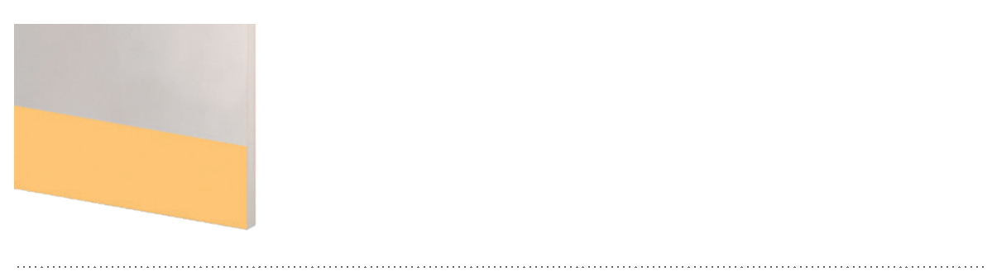
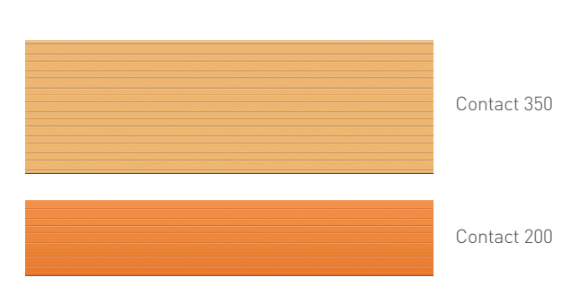

SPECIFICATION

FOOT-HEIGHT DOOR
CONTACT ADHESIVE PROTECTION PLATES

- Description: adhesive protection plate (Contact 350 or 200 as manufactured by SPM) from smooth and antibacterial PVC achieving Bs2d0 fire rating with solid colour. PVC profile is 350 or 200 mm high and 2.5 mm thick. It provides a smooth surface finish with decorative grooves. A protective film is specified to minimize cleaning before acceptance. It is provided with 2 or 3 strips of foam adhesive tape for fixing.
- Environment: no heavy metals and no substance potentially subjected to any REACH restriction are used in its manufacture, nor PBT/BPA. The calcium-zinc thermal stabilisation process is used. The emission level of volatile substance in inside air has been tested according to ISO 16000-6 and is very low (A+) according to the French regulation (23 March 2011 nr 2011-321 Decree and 19 April 2011 Order). 100% of the product are recyclable.
- Colour: selected by architects from manufacturer’s standard range.
- Installation method: adhesive. SPM universal mastic glue is recommended for stronger fixing.
